Specific Focus | Task: Student Directions | Example
Step 1:  Logging On | - Turn on a Chromebook  - Do NOT log in  - Click “Apps” in the bottom left  - Select AIRSecureTest | 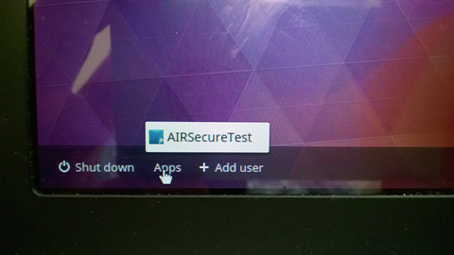
 | - Click the link that says “Click here to go to the Practice and Training Test Site” | 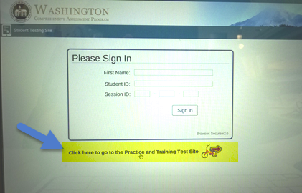
 | - Just click “Sign in” as a guest. | 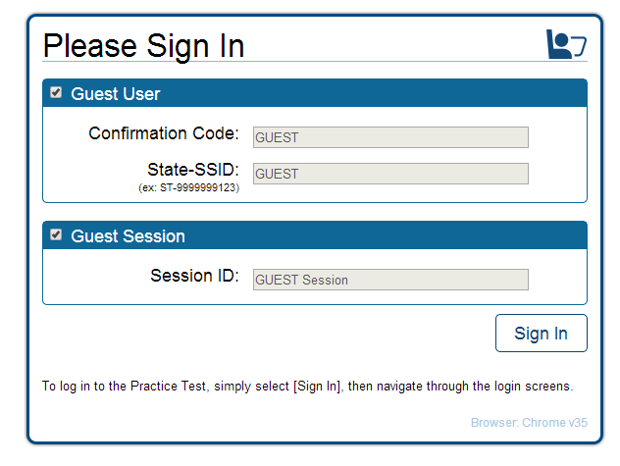
Step 2:  Sign in | - Choose your grade level.  - Click “Yes” to start. | 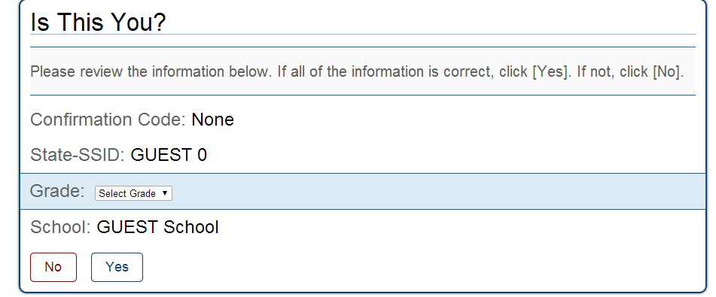
Step 3:  Test Choices | - Click Start ELA Grades 6-8 Training Test.  - Continue sign in process and click the button to Begin Test Now.  - On the screen for Choose Settings, click Select.  - On the screen, Is This Your Test? scroll down and select, Yes, Start My Test. | 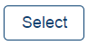  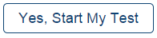    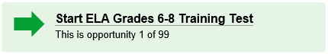
Step 4:  Sound Check | Plug your headphones into the “headphone icon” of your computer station.  Click the sound icon to “hear” the sound.  If you hear the sound, click “yes” and if not, check to be sure your headphones are plugged into the correct location of your computer.  - You can adjust the sound on the Chromebooks using the volume keys on the upper right part of the keyboard | 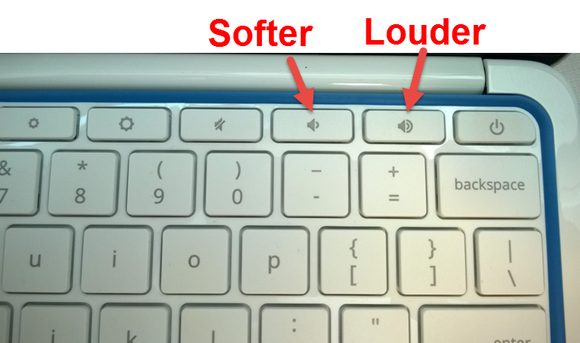  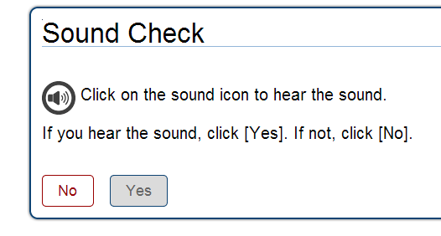
Step 5: Review Test Instructions & Help | - In this section of the test, it is helpful to scroll through the information about the tools you will encounter within the testing interface.  - Here you will find an overview of the student testing site, tools, and test rules.  - After review, click the Begin Test Now button. |   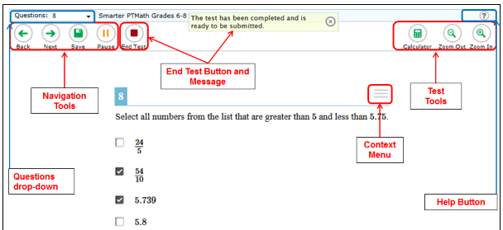
Step 6:  Select & Highlight Text | - In the first passage, click and hold the touchpad at the end of a sentence.  - With another finger drag/swipe to the left and up to select the entire sentence.  - In the upper right corner click the three lines to bring up the menu.  - Using the touchpad, select Highlight Selection.  - You will now see the passage highlighted in yellow.  - To remove the highlighted passage click the three lines to bring up the menu then using the touchpad, select Reset Highlighting.  *Highlighting can be done on both the reading passage and on the questions.  **If you leave the test segment or pause the test, any highlighting up until that point will not be retained. | 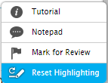  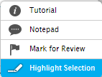    
Step 7:  Strikethrough | - Locate a multiple choice question to use for the next practice.  - Using the touchpad with two fingers, right-click on the answer you want to mark.  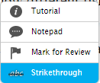  - Then click the Strikethrough button that pops up. That answer will now show a line through it.  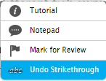  - To remove the strikethrough, right-click the answer and then click the reset/undo strikethrough button that pops up.  If you have specific learning accommodations, please ask your teacher for help on this screen.  *Used to mark off the answers you do not wish to choose for a particular question.  *Using the strikethrough doesn’t mean you have chosen an answer for that question.  *Strikethrough also does not mean you can’t choose that answer as a response. | 
Step 8:  Stimulus Expansion | - There may be times when you would prefer the text of the test question to be full screen.  - On your screen locate the double arrow button next to the context menu. This is the Stimulus Expansion button.  - Click the button once and your text will expand to cover the entire window.  - Click the button again, and it will return to cover the left half of the open window leaving the test question on the right half of the window. | 
Step 9:  Reflection | Now that you have completed the practice using the highlighter & strikethrough tools, reflect and respond to the following questions on this document or open a new Google Document and SHARE it with your teacher. | - Describe two challenges or successes you encountered when using the highlighter and/or strikethrough tools on the practice test using a Chromebook.  - Did you know you can also use these tools on the SBAC Math Assessment? Give an example of how you could use these tools on the SBAC Math assessment.
 | On a scale of 1-10 how you’re your comfort level with these tools?  8-10 I feel comfortable with the tools but I could redo this lesson for additional practice.  5-7 I am somewhat comfortable with these tools but could use additional practice.  0-4 I am still not comfortable with these tools and need to complete the practice again. | - If you gave yourself a rating of 8-10, what can you do to help other students achieve the same score?  - If you did not get give yourself a rating between 8-10, what do you plan to do to improve your score?

